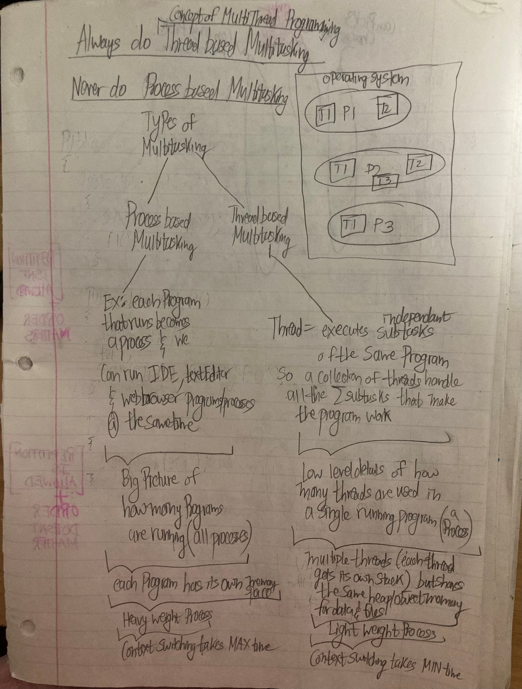

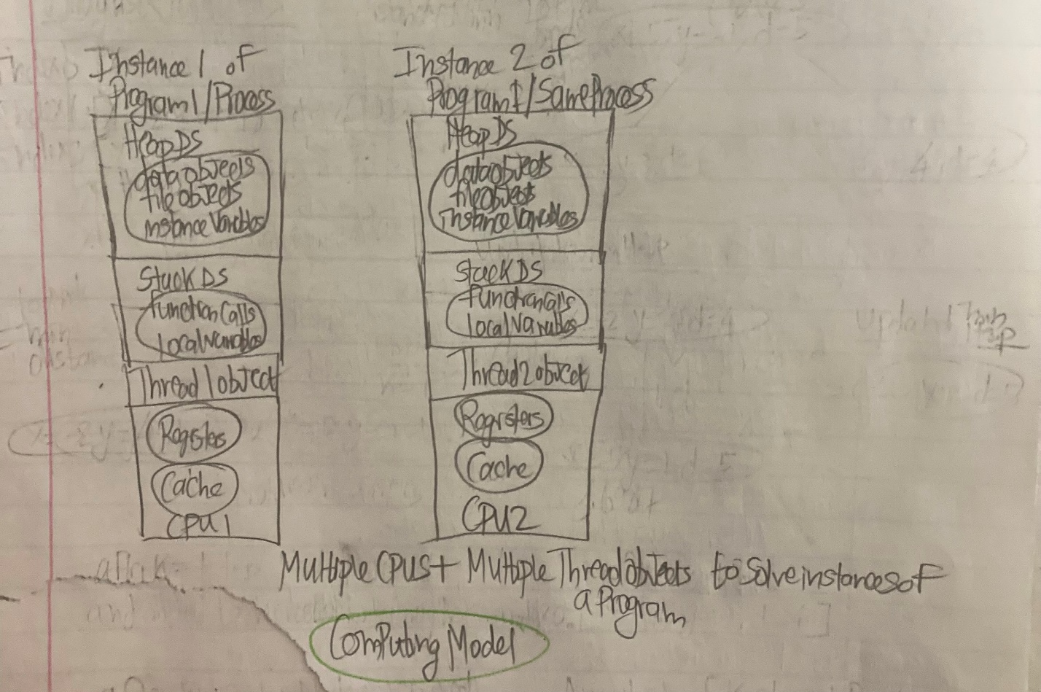

Step1: creating a working **rest api server**

Step2: creating fake data

Step3: doing mvc coding of **rest api server**

Step4:Using postmap app to verify that all the **rest api services** are working

Step5:logging into H2 database in the web browser to verify that the db table has data

